

Statement and Confirmation of Own Work

**A signed copy of this form must be submitted with every assignment.**

**If the statement is missing your work may not be marked.**

**For Level 7 assignments, please use the separate Level 7 Candidate**

**Statement of Own Work form instead of this one.**

**Student Declaration**

I confirm the following details:

|  |  |
| --- | --- |
| **Candidate Name:** | Saw Myat Mon Hnin |
| **Candidate ID Number:** | 202692 |
| **Qualification:** | Level-5 diploma in Computing |
| **Unit:** | Dynamic Websites |
| **Centre:** | Strategy First University |
| **Word Count:** |  |
| I have read and understood both NCC Education’s *Academic Misconduct Policy* and the *Referencing and Bibliographies* document. To the best of my knowledge my work has been accurately referenced and all sources cited correctly.  I confirm that I have not exceeded the stipulated word limit by more than 10%  I confirm that this is my own work and that I have not colluded or plagiarised any part of it. | |
| **Candidate Signature:** | Myat |
| **Date:** | 2/8/2024 |

Contents

Task-1 3

**HTML** 4

Task-2 10

**CSS** 11

Task-3 17

**Critical Evaluation of the “Online Safety Campaign” Website** 18

**Introduction and Appraisal of Web Services** 18

**Benefits for Users** 18

**Use of Web Development Tools** 19

**Evaluation of the SMC Website** 20

Task-4 21

**Reflection on Website Development** 22

**Development Process** 22

**Learning Outcomes** 22

**Future Improvements** 22

# Task-1

## **HTML**

Index.php

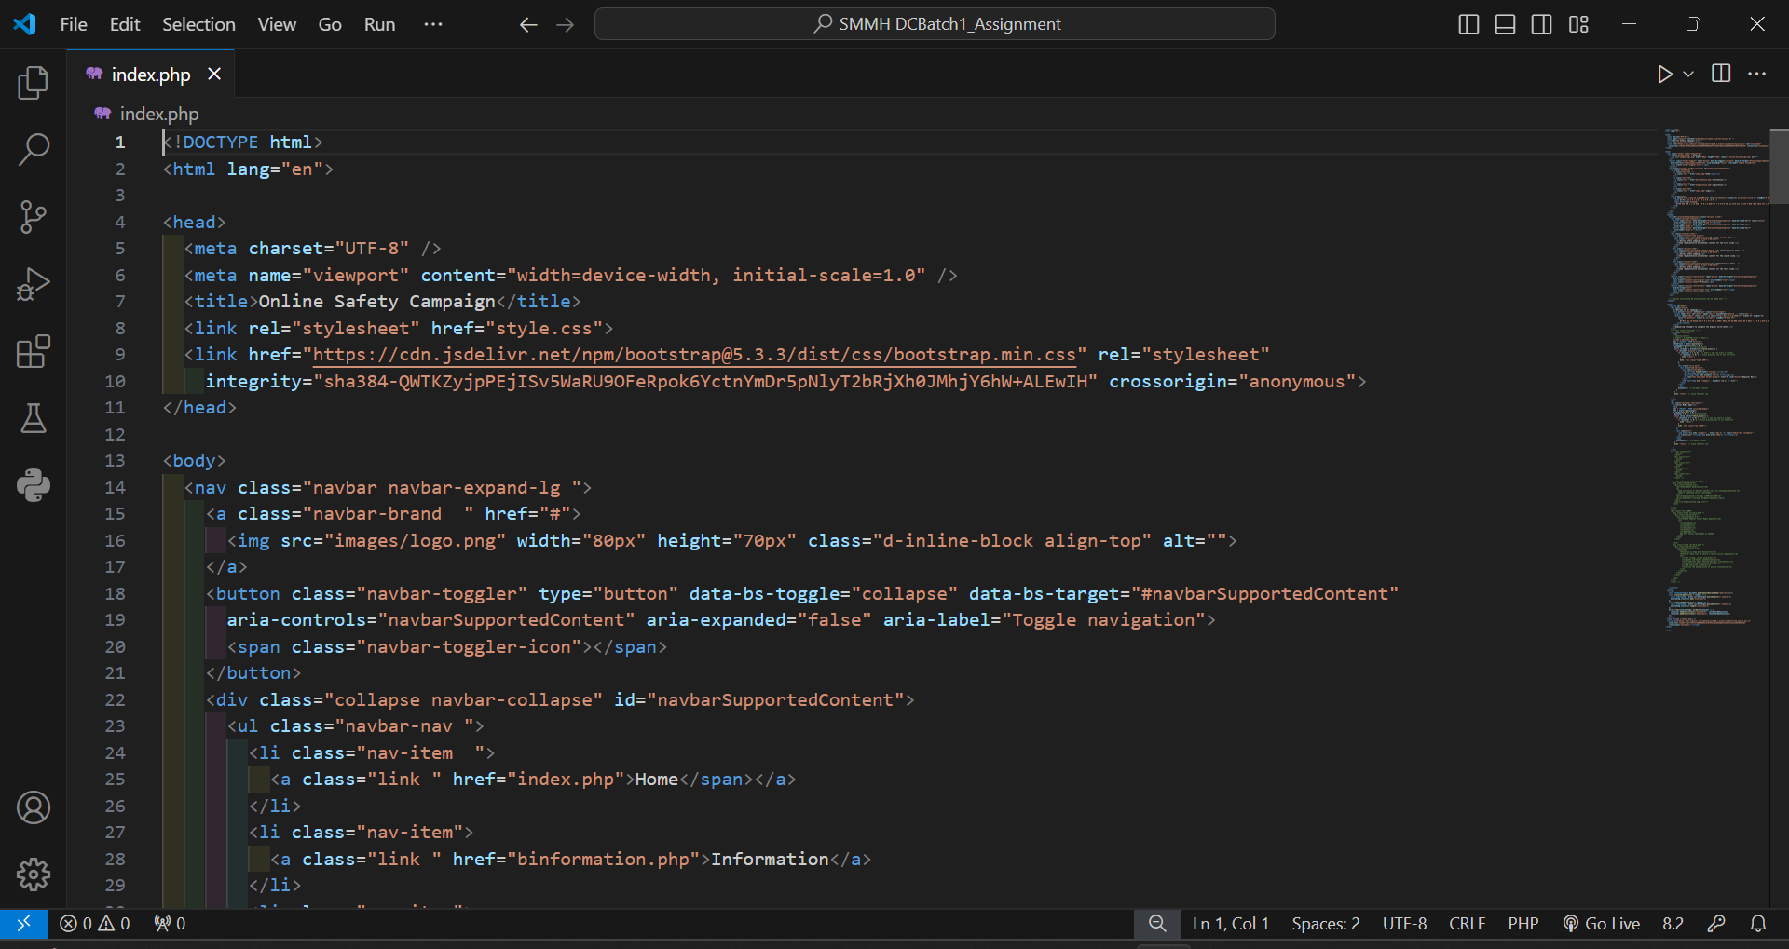

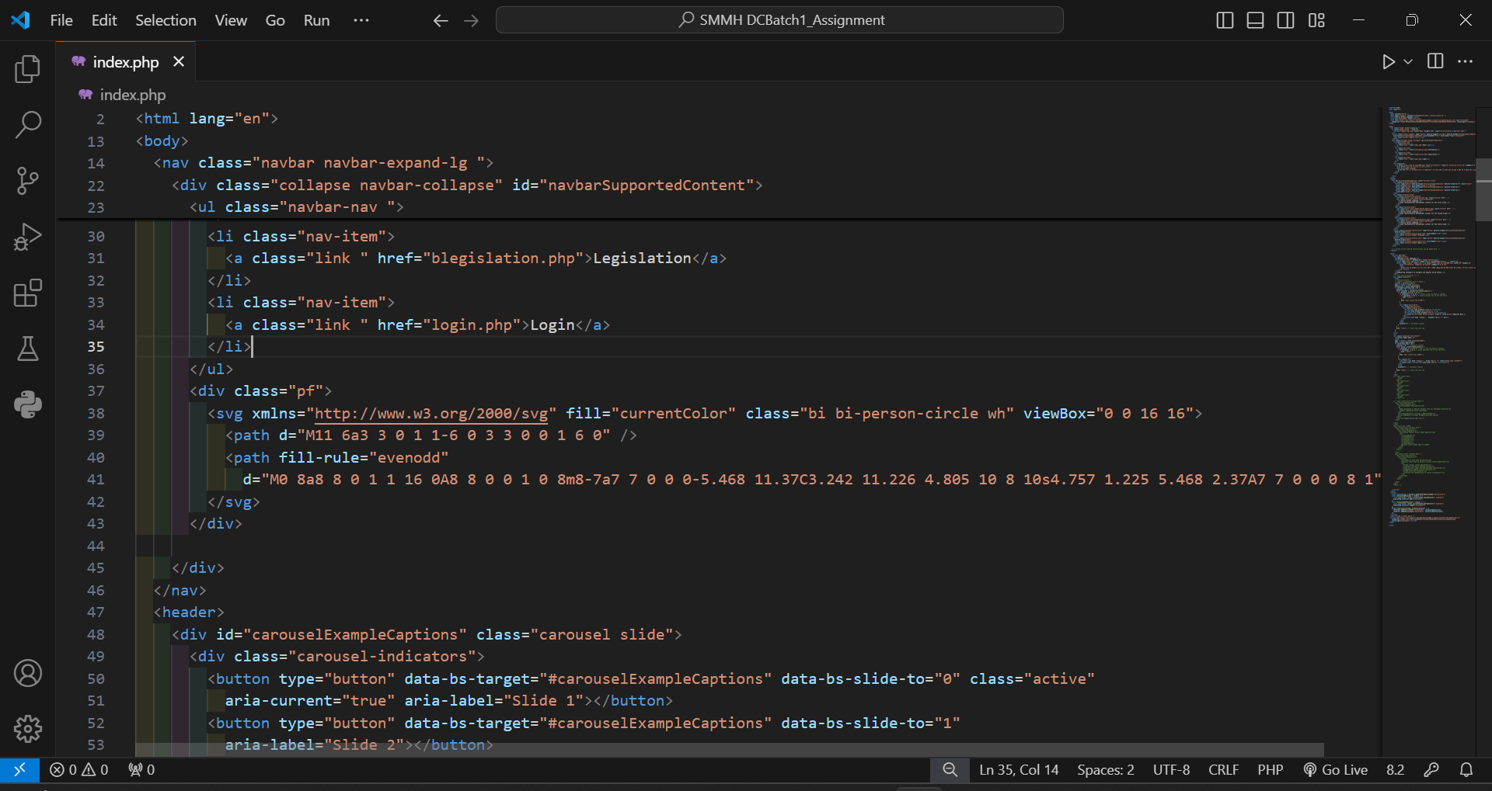

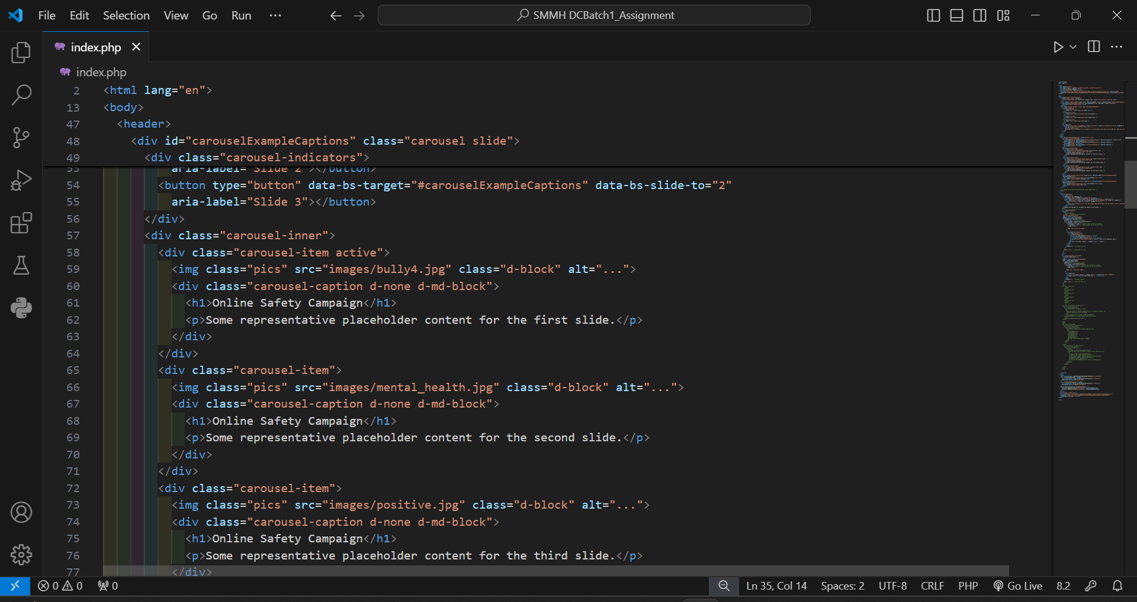

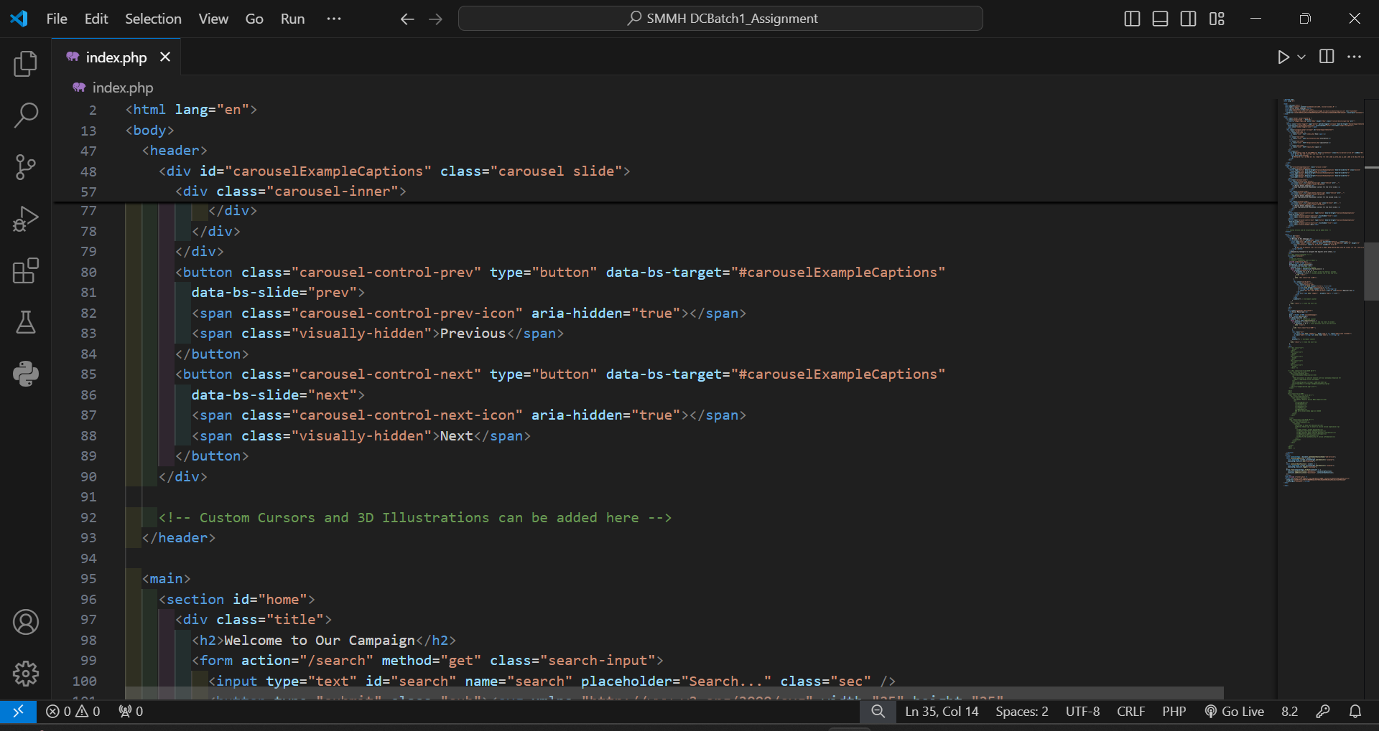

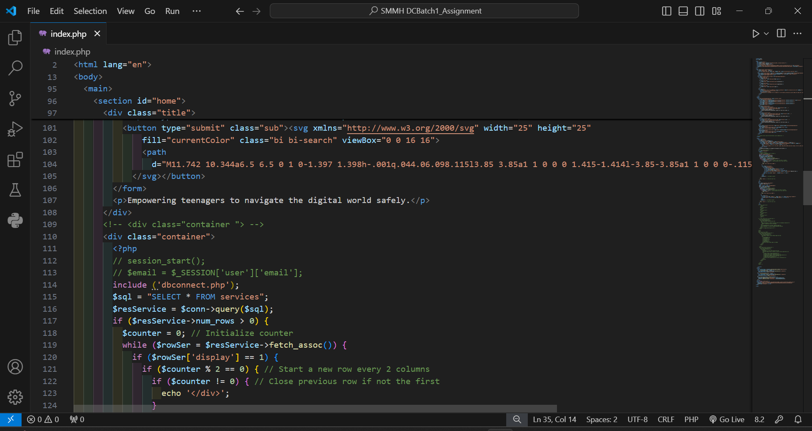

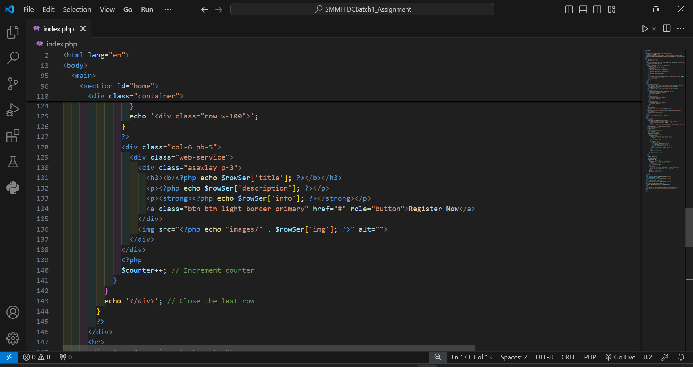

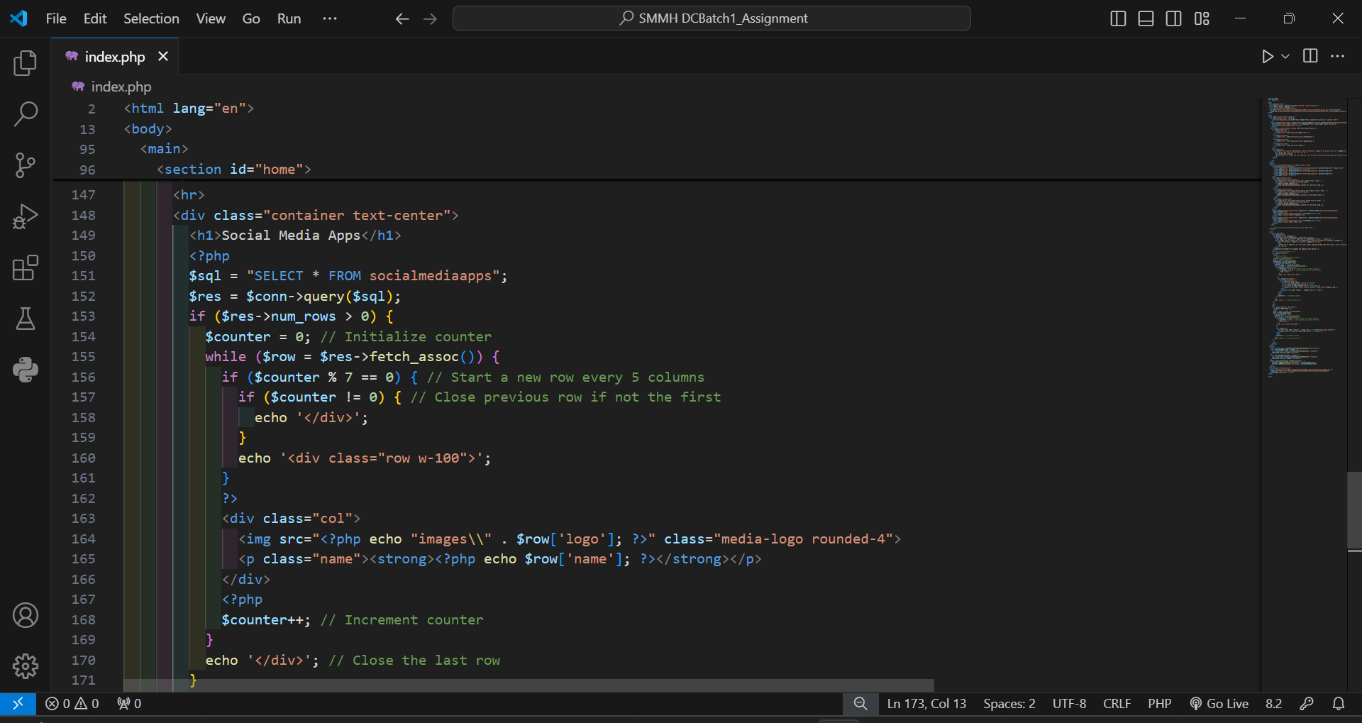

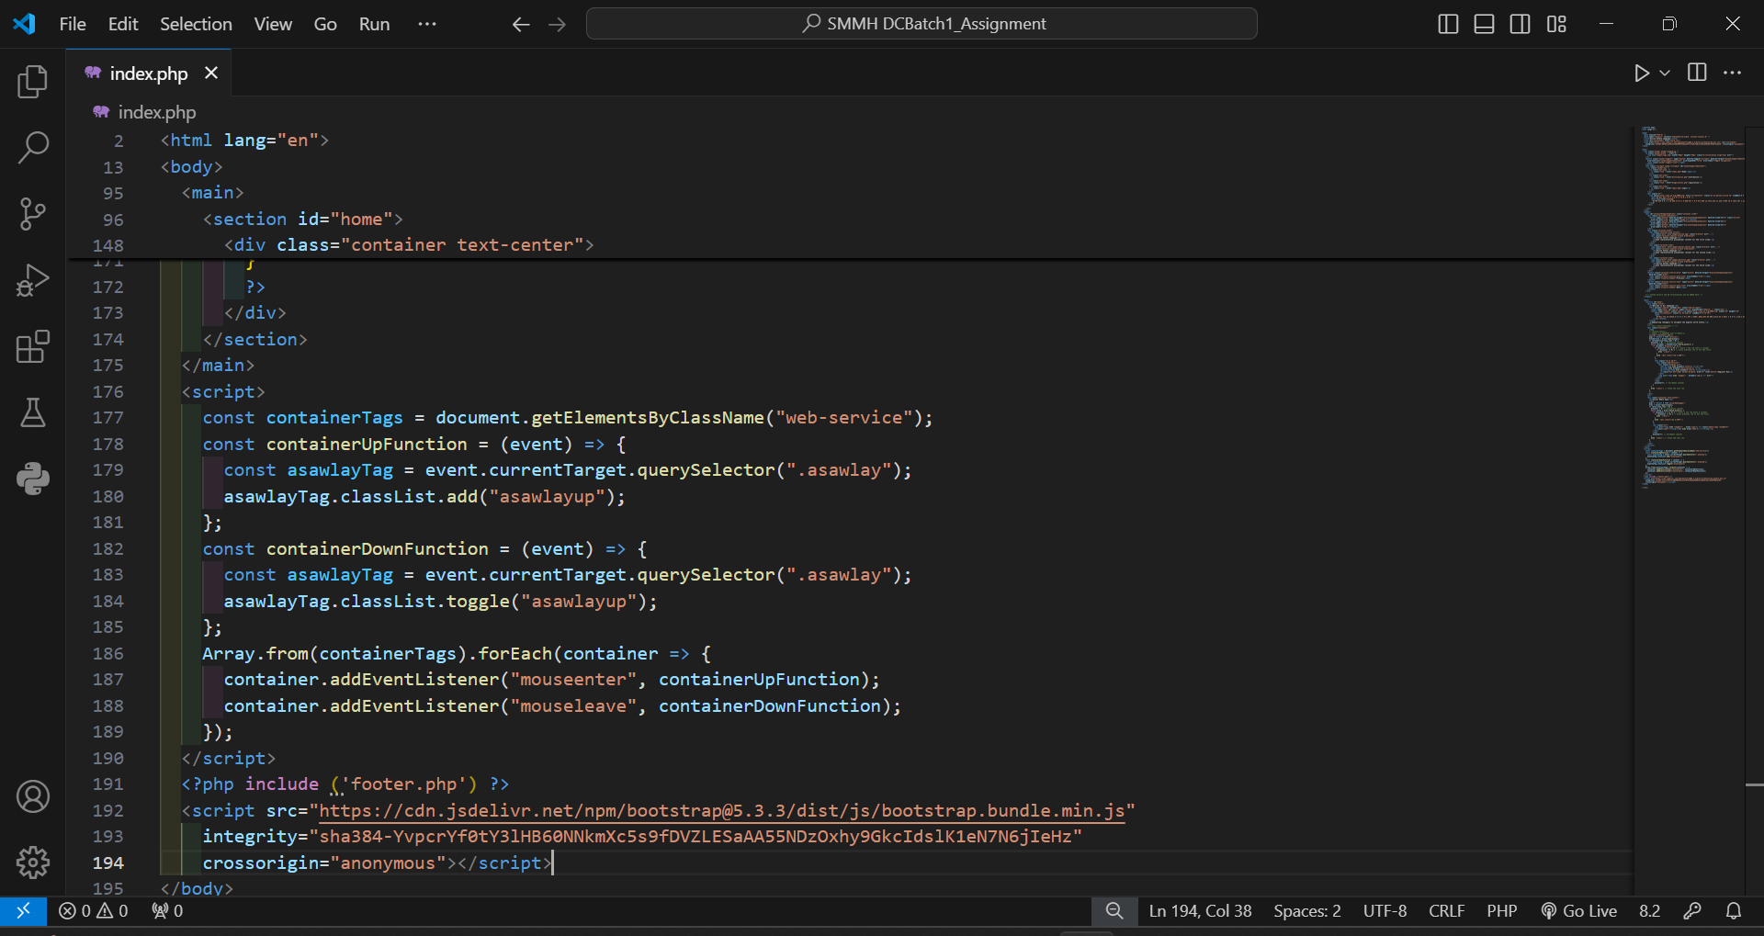

Result of index.php

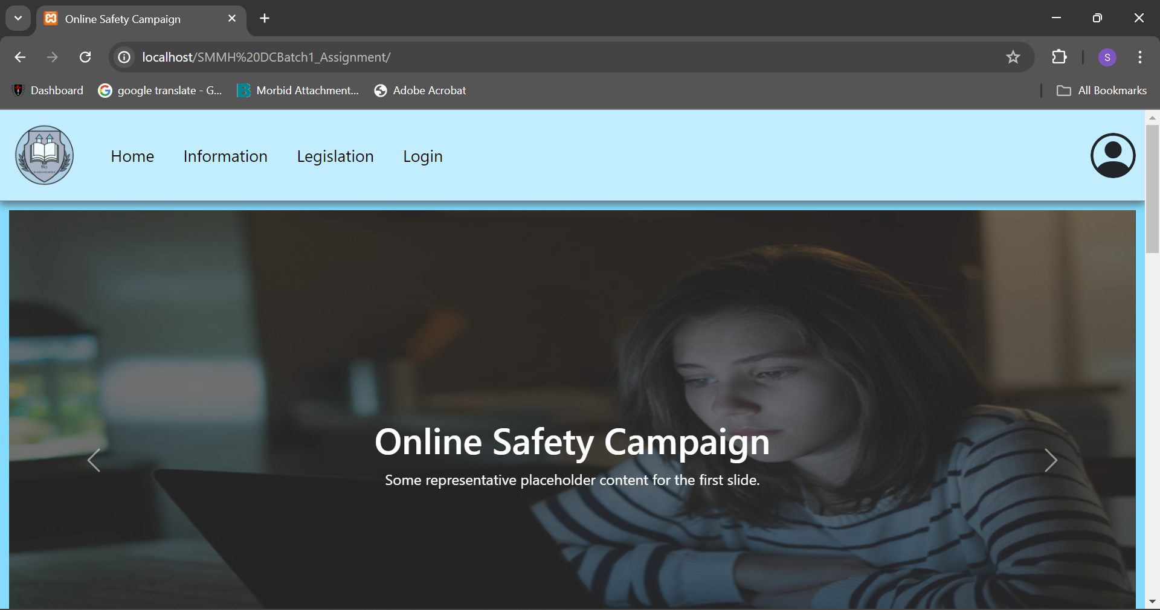

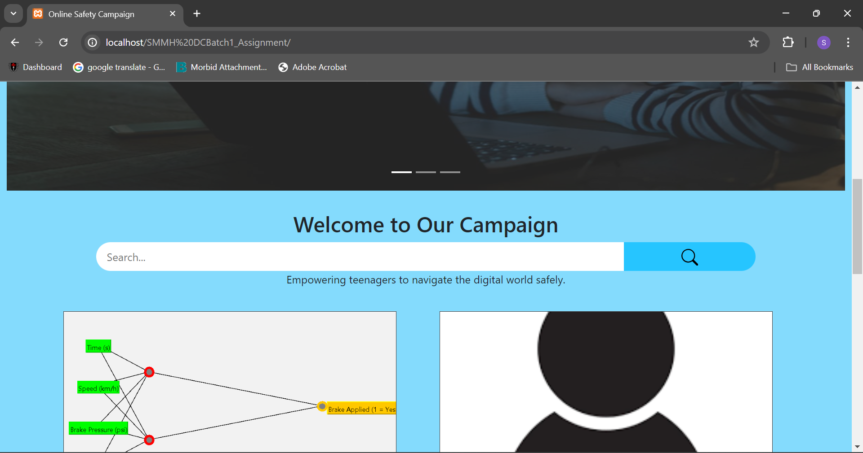

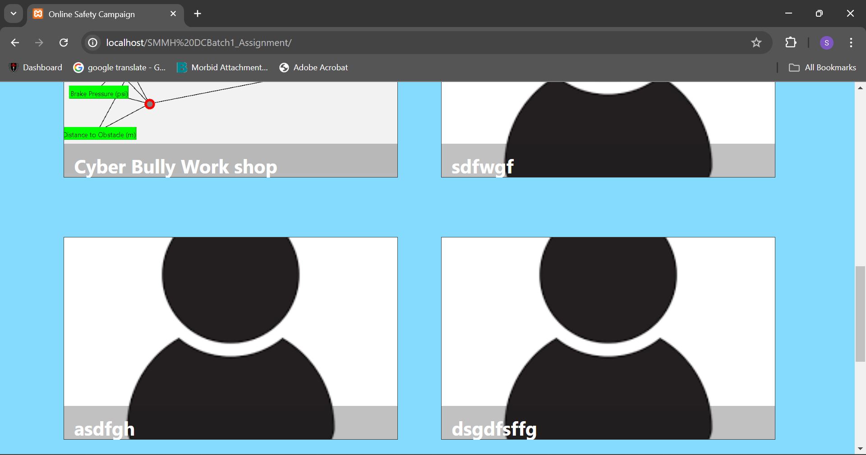

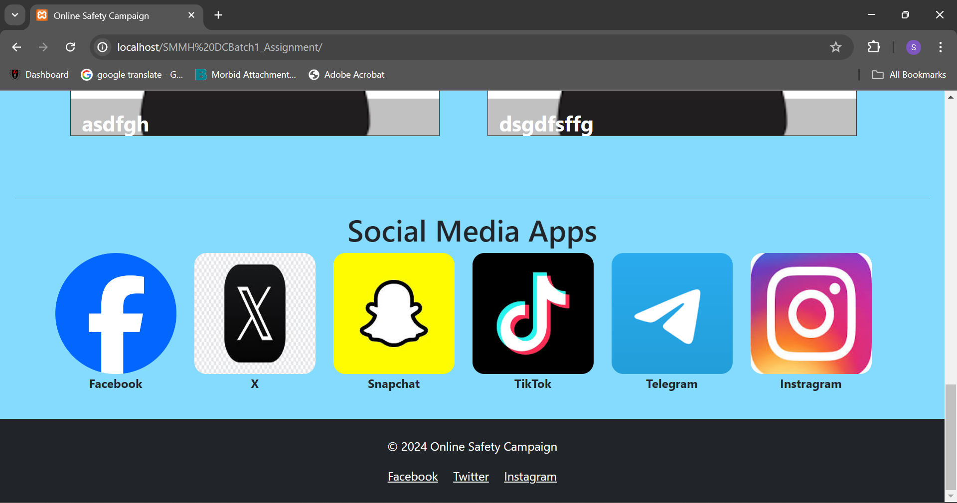

# Task-2

## **CSS**

style.css

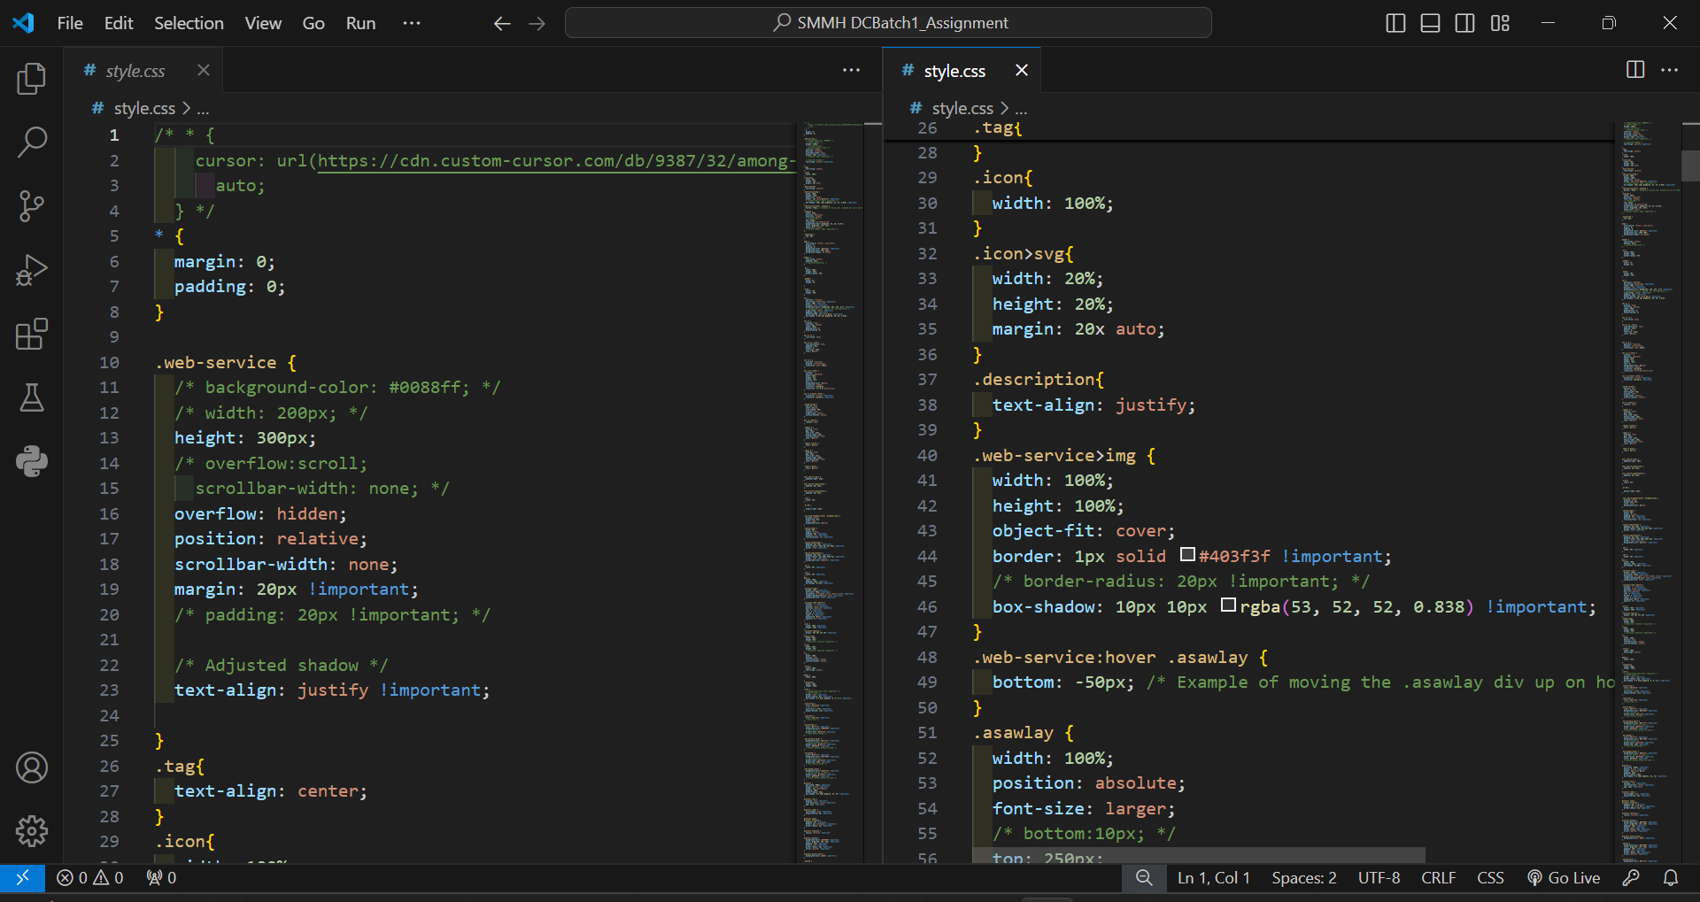

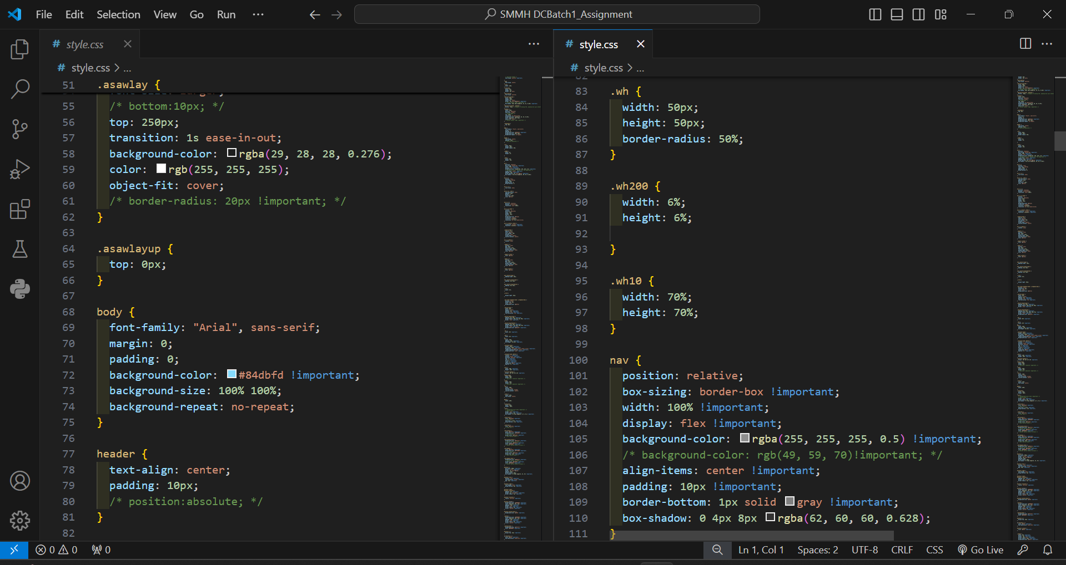

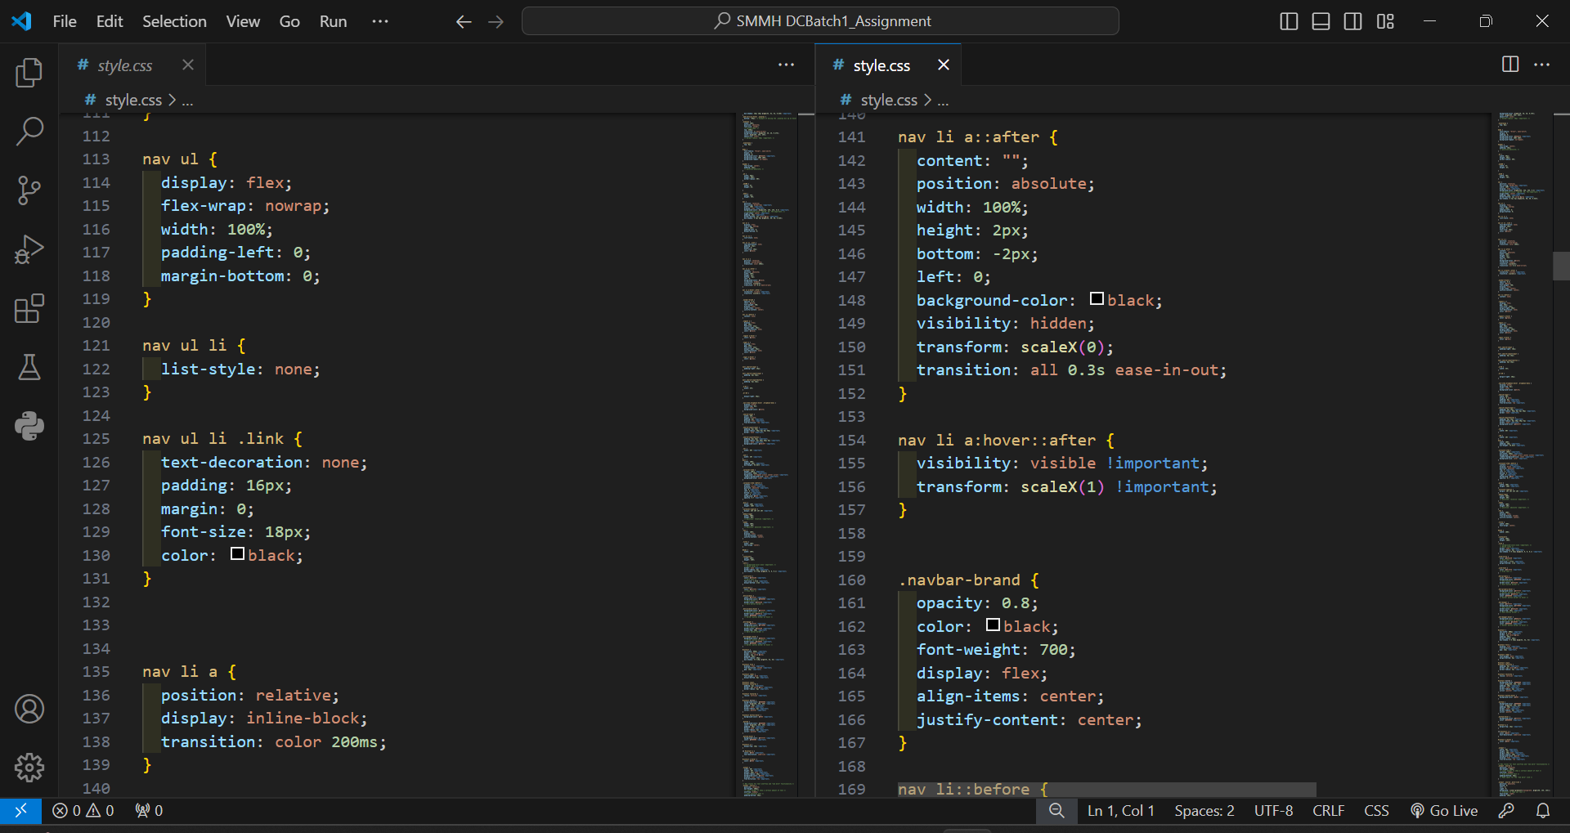

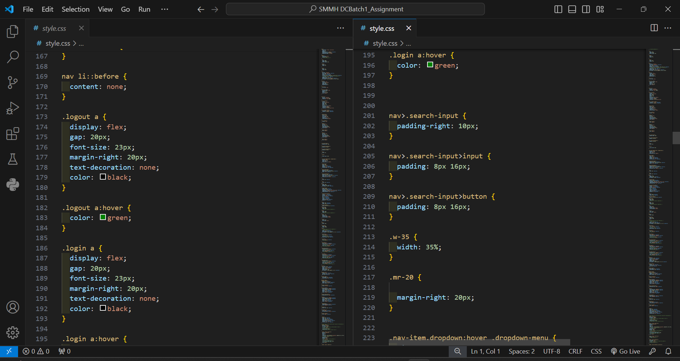

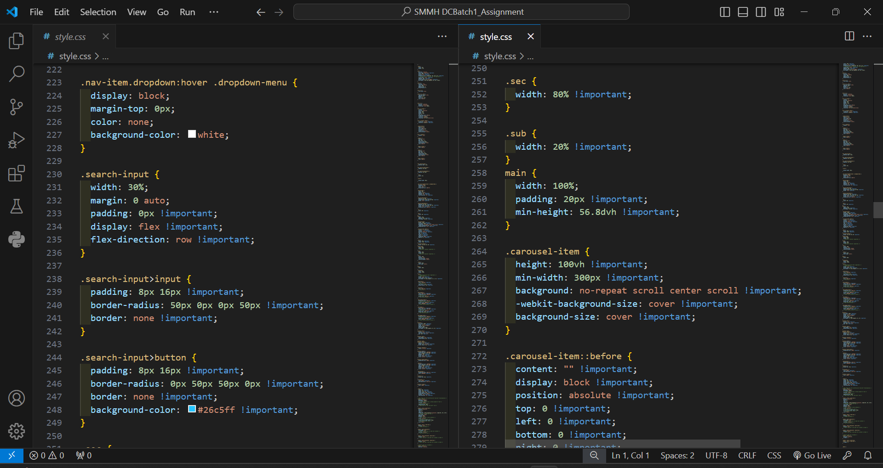

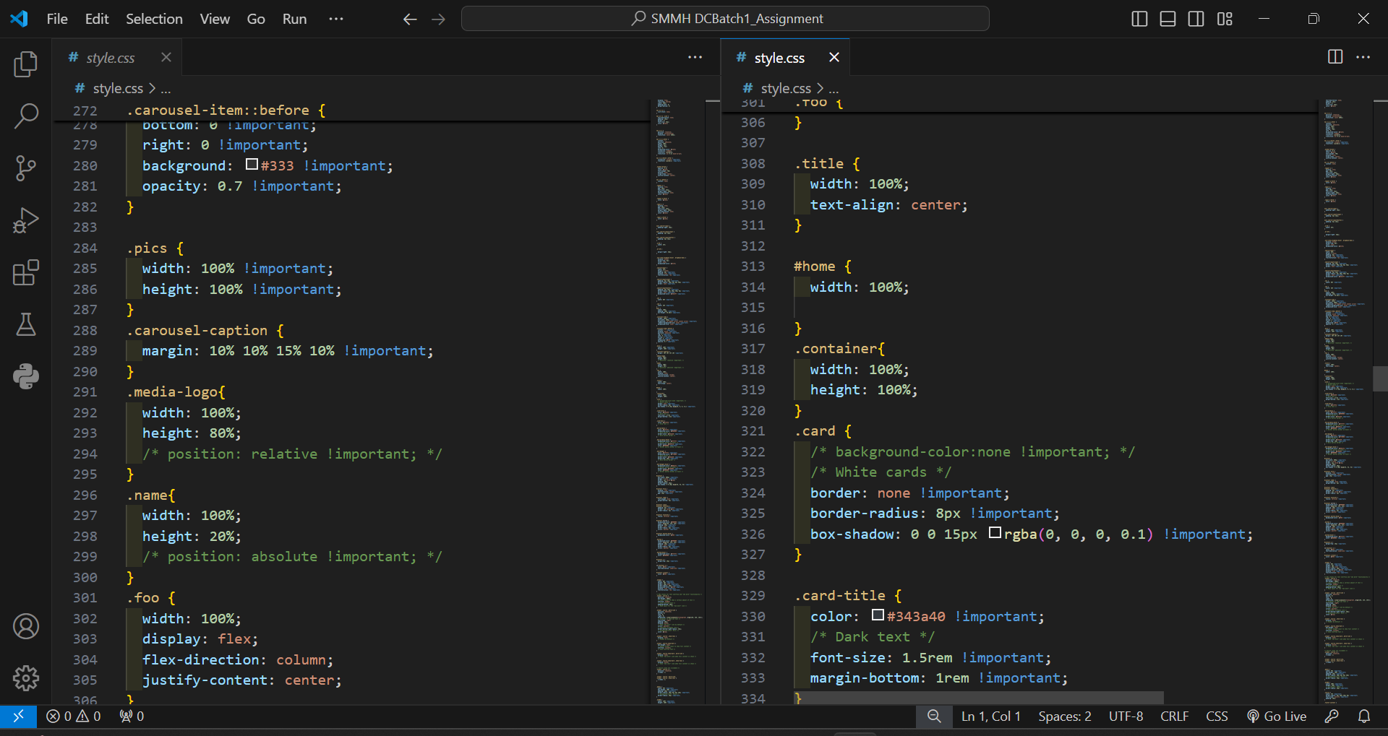

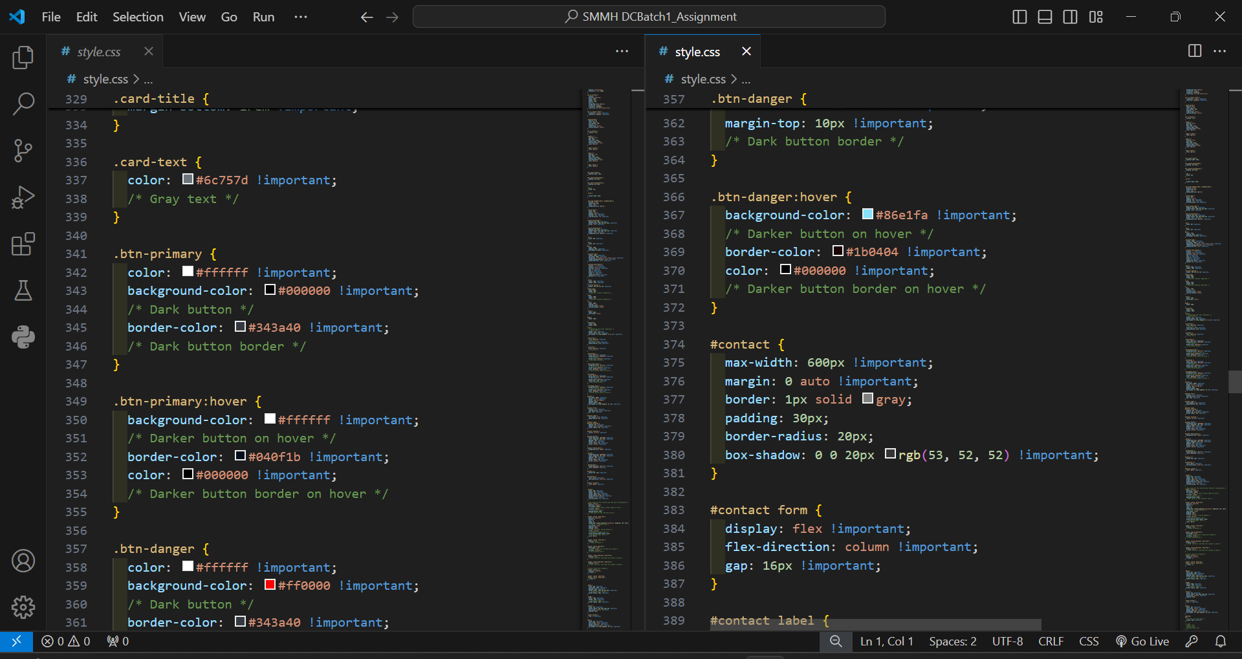

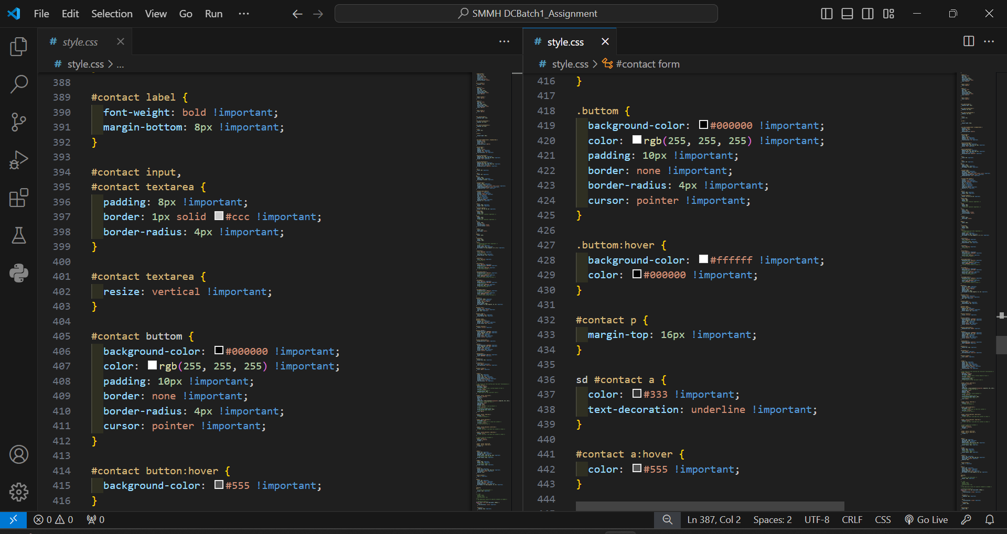

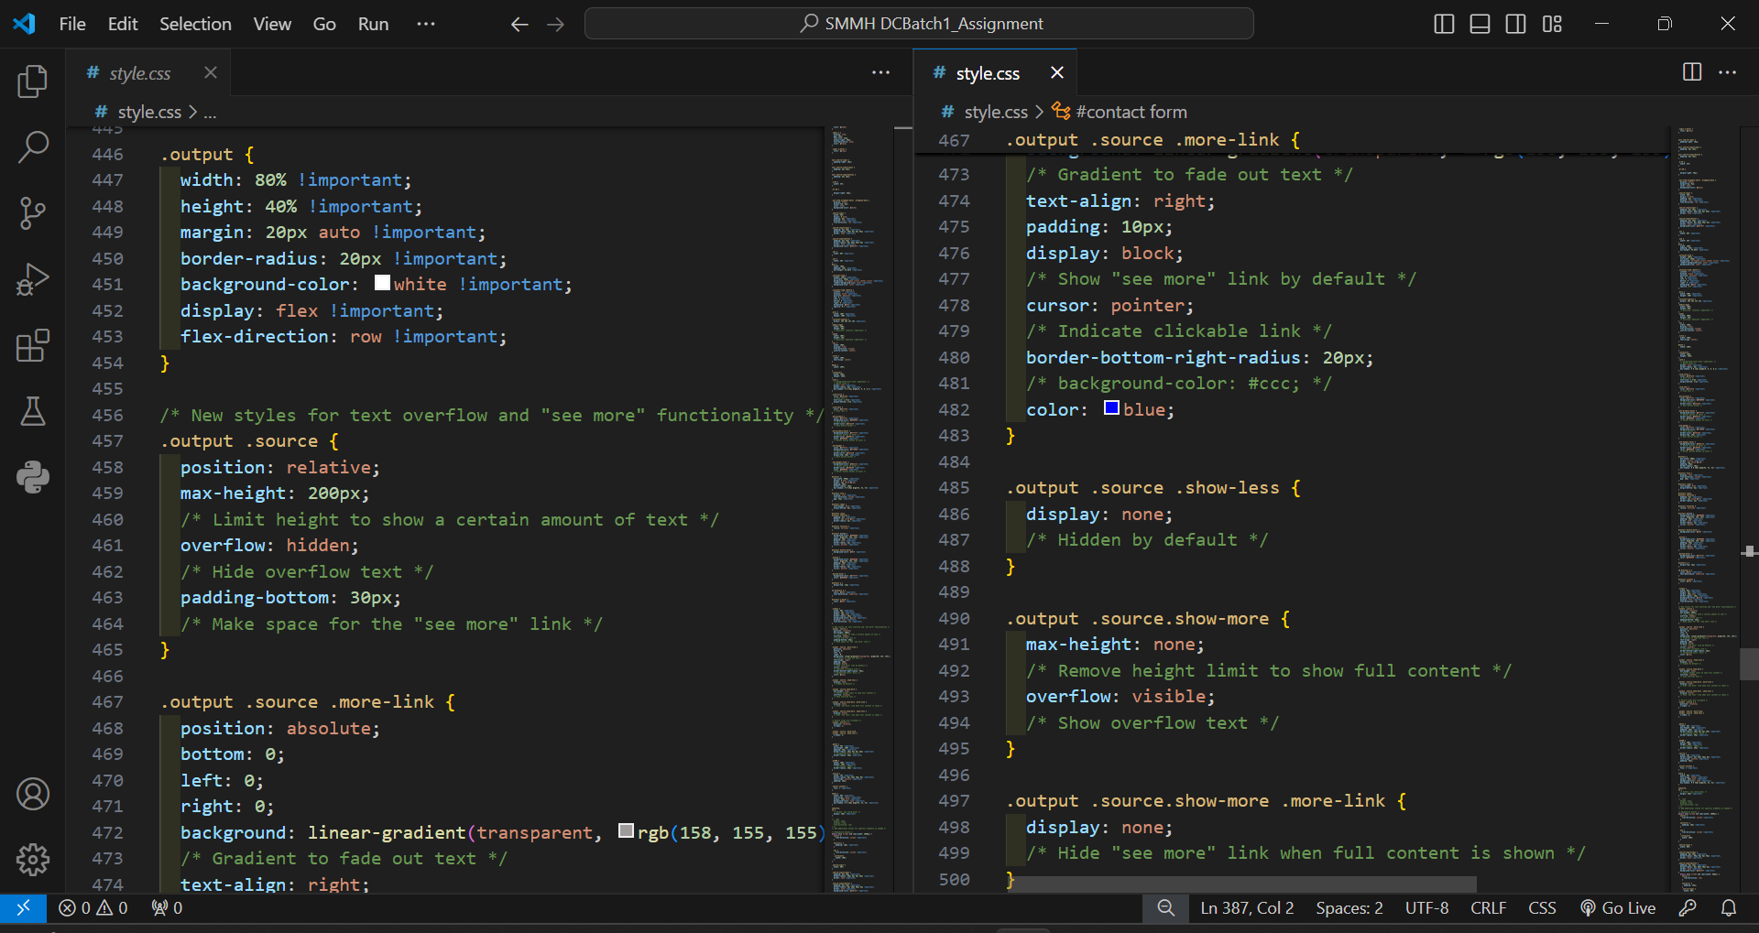

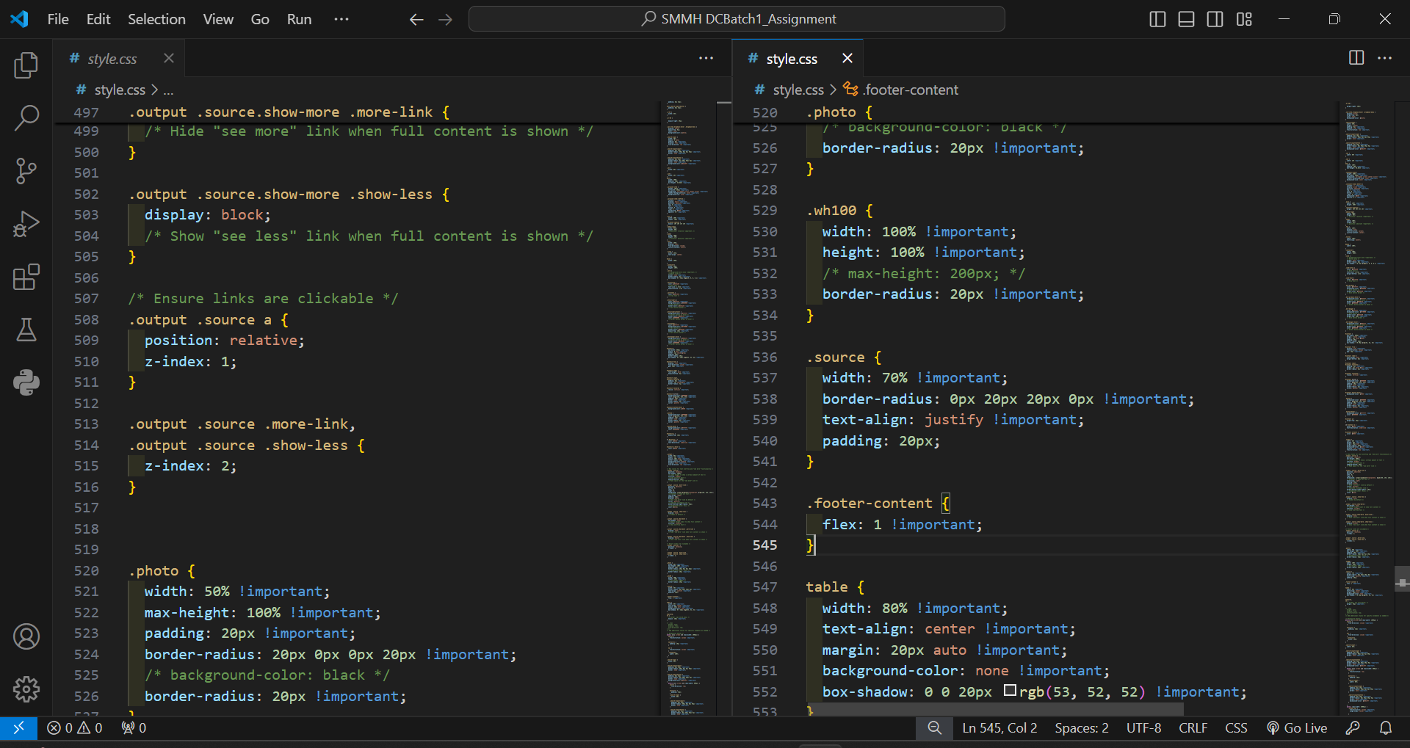

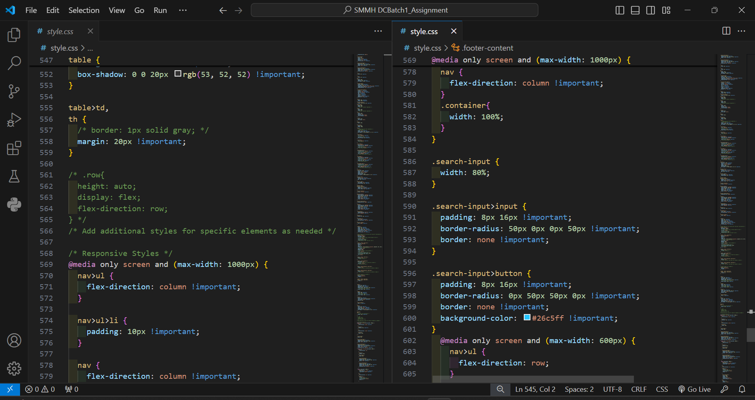

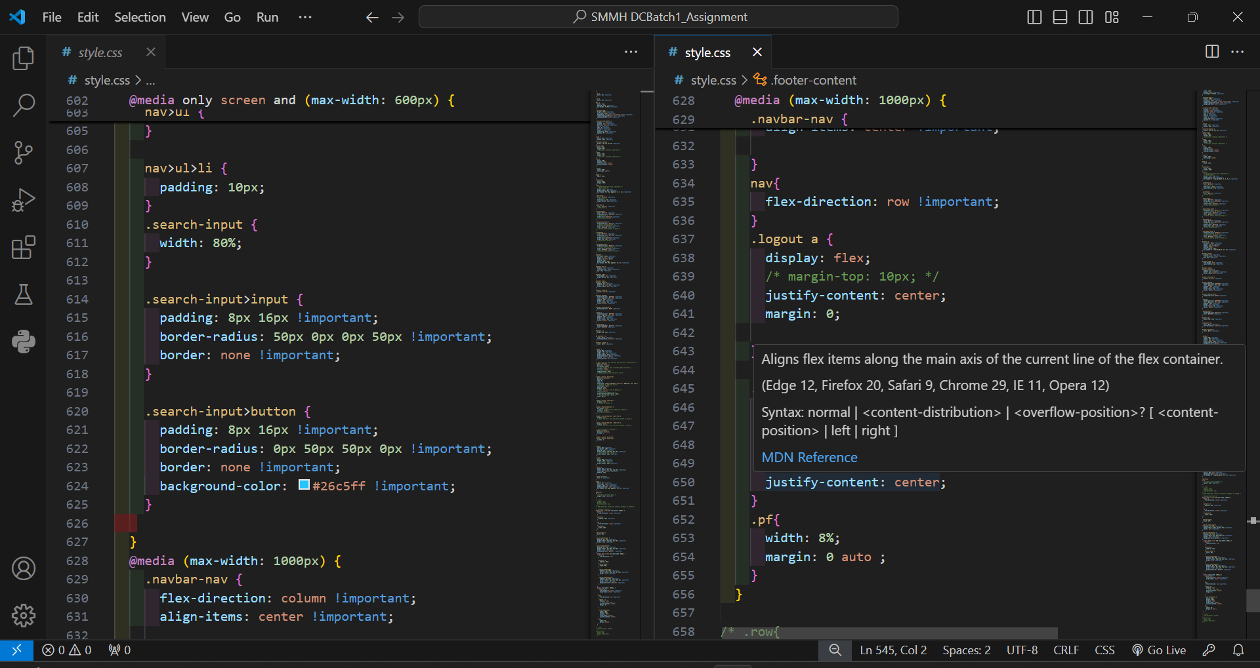

# Task-3

## **Critical Evaluation of the “Online Safety Campaign” Website**

### **Introduction and Appraisal of Web Services**

The integration of web services into the SMC website, designed to educate and empower children, teenagers, and parents about online safety in social media, offers numerous potential benefits. Web services enable interoperability between different software applications running on various platforms, enhancing the functionality and accessibility of the website. For SMC, web services can provide real-time data exchange, improve user interaction, and streamline the delivery of educational content. For instance, integrating a web service for real-time updates on online threats can ensure that the safety information provided is current and relevant, thereby improving the website’s effectiveness in educating users.

### **Benefits for Users**

The SMC website provides several key benefits for its users, enhancing their online experience and safety awareness:

1. Access to Real-Time Information

Users can access up-to-date information about online threats and safety practices. Web services enable the website to fetch to the latest data from trusted sources, ensuring users receive the most current advice and news about online safety.

1. Interactive Educational Resources

The website features interactive elements such as quizzes, videos, and articles tailored to different age groups. These resources engage users in a dynamic learning experience, making it easier for children, teenagers, and parents to understand and remember safety practices.

1. Personalized User Experience

The website’s design caters to different user groups (children, teenagers, and parents) by providing content specific to their needs and comprehension levels. This personalized approach ensures that each user finds relevant and appropriate information, making the learning process more effective.

1. Enhanced Security Features

Through PHP and web services, the website implements secure user authentication and data storage practices. This ensures that users’ personal information is protected, fostering a safe online environment for learning about internet safety.

1. Convenient and User-Friendly Interface

The use of HTML and CSS creates a visually appealing and easy-to-navigate website. A responsive design ensures that the website is accessible on various devices, allowing users to learn about online safety anytime, anywhere.

### **Use of Web Development Tools**

**Visual Studio Code (VS Code)**

VS Code is an efficient and user-friendly integrated development environment (IDE) that offers a plethora of features beneficial for web development. Its rich extension ecosystem allows for enhanced functionality, such as real-time collaboration, debugging tools, and code linting. In developing the SMC website, the auto-completion and syntax highlighting features in VS Code significantly improved the speed and accuracy of coding, particularly in HTML, CSS and PHP. These features were crucial in maintaining high code quality and efficiency throughout the development process.

**XAMPP**

XAMPP is a cross-platform software stack that include Apache, MySQL, PHP, and Perl. It provides an excellent local server environment for testing and development purposes. Using XAMPP, the SMC website development process was streamlined as it allowed for quick setup and management of the local web server. This tool enabled the simulation of the live server environment, ensuring that the website would function correctly once deployed. The integration of MySQL with PHP through XAMPP allowed for efficient database management and testing.

**Use of PHP for Database Design and Build**

PHP is a powerful server-side scripting language that is widely used for web development. For the SMC website, PHP was employed to design and build the website database. This involved creating scripts for database connections, executing SQL queries, and handling data retrieval and storage. The use of PHP ensured a dynamic and interactive user experience. For example, the website includes educational resources and quizzes that require user interaction and data storage. PHP scripts manage user data securely, storing it in the MySQL database and retrieving it as needed. PHP’s ability to interact seamlessly with MySQL facilitated the creation of a robust and efficient database system for the SMC website.

### **Evaluation of the SMC Website**

The SMC website, built using PHP, HTML, CSS, and XAMPP, was made to achieve key goals: increasing user engagement, giving real-time safety information, and ensuring a smooth user experience. The website looks nice and is easy to use thanks to HTML and CSS. It includes interactive features like quizzes, feedback forms, and dynamic content, which are added using PHP and JavaScript. This makes the website engaging and works well on all devices because of its responsive design. It has information tailored for children, teenagers, and parents, making it relevant and interesting. Web services on the site provide real-time updates on online threats and safety tips, ensuring users get the latest information. By using PHP for backend processing and database management, and adding real-time data through web services, the website meets its educational goals. The use of tools like VS Code and XAMPP made the development process smooth, resulting in a stable and effective website.

# Task-4

## **Reflection on Website Development**

### **Development Process**

The development of the SMC website utilized several tools: Visual Studio Code (VS Code) for coding, XAMPP for setting up a local server, and PHP, HTML, and CSS for creating the website. VS Code’s features like auto-completion and syntax highlighting made coding efficient. XAMPP was helpful for testing the website locally, ensuring functionality before going live. The use of PHP for backend processing and database management allowed for dynamic content and interactive features such as quizzes and feedback forms. While most tools worked well, challenges arose with integrating web services for real-time updates, requiring additional learning and troubleshooting.

### **Learning Outcomes**

This process provided a deeper understanding of web development, revealing how different tools and technologies come together to create a functional website. The importance of user-friendly design became evident, along with the need for responsive design to ensure compatibility across devices. The project highlighted the value of web services in delivering up-to-date information. Problem-solving skills improved, especially in debugging issues and integrating new technologies.

### **Future Improvements**

Future projects would benefit from mor through planning, including a detailed timeline and clearer milestones. Investing more time in learning about web services and advanced features before starting would be advantageous. Seeking more feedback during the development process could help identify and fix issues early. This approach would aid in better time management and result in a more polished final product.

Reference

1. www.unicef.org. (2022). Evaluating Online Safety Initiatives | UNICEF East Asia and Pacific. [online] Available at: <https://www.unicef.org/eap/reports/evaluating-online-safety-initiatives?gad_source=1&gclid=CjwKCAjwnei0BhB-EiwAA2xuBp8f_ek2Km-1MuZ7H9BWqI_yAO1LZg5Klj-rWNL11c3NjSicSxs4sRoC9WcQAvD_BwE>. Accessed Date: 2-06-2024.
2. Inhope.org. (n.d.). INHOPE | Online Safety through Youth Empowerment. [online] Available at: <https://inhope.org/EN/articles/online-safety-through-youth-empowerment>. Accessed Date: 3-06-2024.
3. Sharman, T. (2015). Web Development. [online] Medium. Available at: <https://medium.com/@TOMSHARMAN/web-development-fc60c2009a06>. Accessed Date: 15-06-2024.